Khwanruethai Sae-Tang 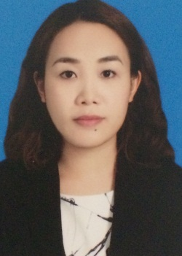

The Met Condo 123/94 Sathorn Rd, Khwang Thungmahamek, Sathorn, Bangkok 10120

083-4199236 | pambery@hotmail.com

# Personal information

Nationality:  Thai Date of birth:  11 April 1986  
Gender:  Female Marital Status:  Single  
Religion: Buddhism

# profile

* I am a highly responsible individual who has the desire and determination to succeed in life.  I have a lot of self-confidence in my own ability.  I am highly patient and I am also a very good team player.  I feel from my previous work experience that I have leadership qualities and I have the ability to work under pressure

# Experience

FB Asia Co Ltd Bangkok

Executive Assistant 2012 – Present

* Provided direct administration support to senior management.
* Managed the calendar, travel arrangements and daily administration tasks for company executive.
* Processed expense reports, ordered supplies, booked and arranged meetings.
* Drafted meeting agendas, supplied advanced materials and executed follow up for meetings and set action plans.
* Wrote reports and correspondence from hand-written notes.
* Co-ordinated with export companies on product delivery times.

The Met Condo Bangkok

Guest Service Attendant 2011-2012

* Welcomed guests in a polite, friendly and helpful manner.
* Being a point of contact for guests should they have any queries.
* Answered telephone enquiries promptly and professionally.
* Arranged tours of the apartments and facilities for the new owners.
* Dealt with and resolved customer complaints.

The Goondiwindi Motel Goondiwindi, Australia

Waitress 2007 – 2008

* Ensured that all guests received exceptional service.
* Inquired about guest satisfaction, anticipated additional needs and happily fulfilled requests.
* Effectively communicated with kitchen staff regarding customer allergies, dietary requirements, and other special requests.
* Effectively used items in stock to decrease waste and profit loss.

# Education

Roi-Et ICEC Roi-Et

High School 2002-2005

* Passed all subjects. A copy of the transcripts can be provided upon request.

Wall Street English Bangkok

Private English School 2012-2014

* Started at intermediate level and progressed to advanced English inc. Business English.
* Top 14 Student in the iBelieve 3 Business Development Scholarship Program
* Published articles in the Wall Street Unshy magazine

# References

Available upon request

**Salary expectation 40,000-50,000 THB**